Steps to checkout, clone and run React EduHub Page

1. Create a folder where you want to clone from master

C:\Users\user1\Documents\Java Workshop\FrontEndMaster 🡪 New folder

1. Open GIT Command prompt and give cd to move to the path of folder. And give command

git init

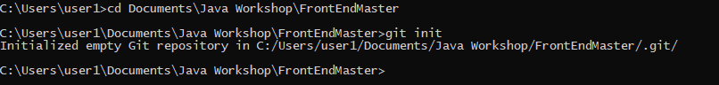

1. In the folder below .git will be created

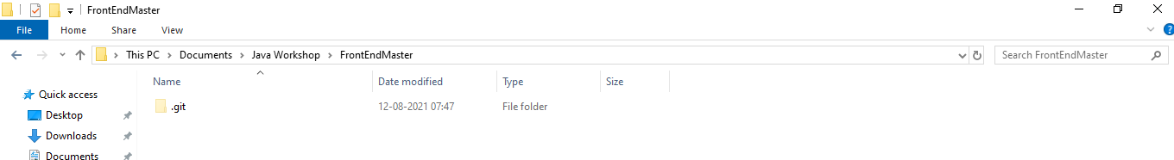

1. Give ‘git clone <https url> command

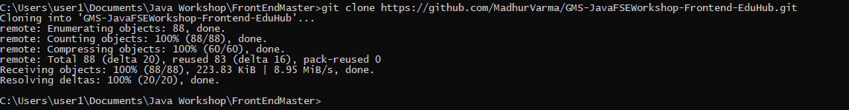

Front end folder will be cloned

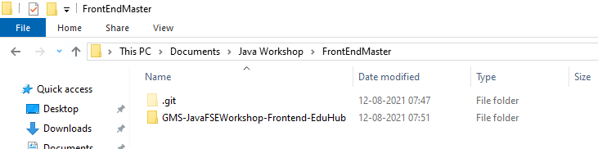

1. Go to Visual Studio Code. Click on File -> Open Folder and select the folder that was just cloned

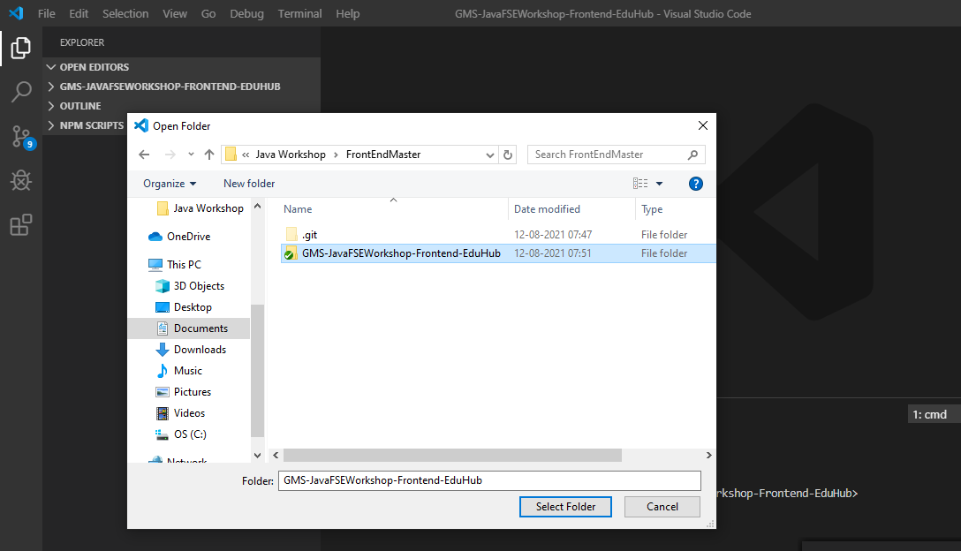

1. Open Terminal and give

**npm I**  to install all the dependencies – this step will take 5 mins

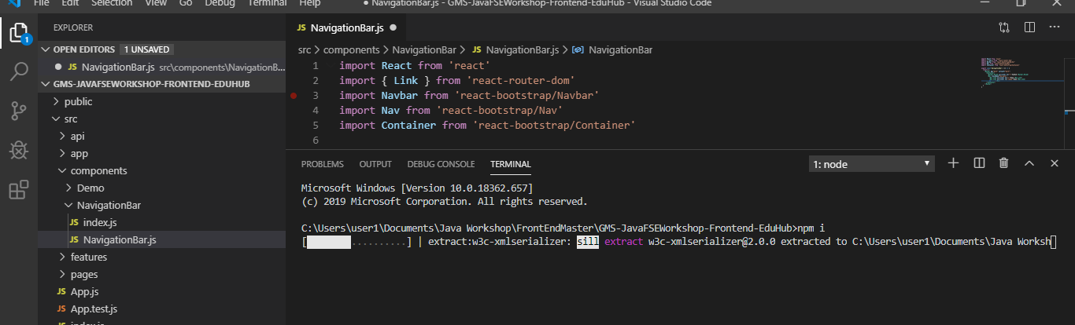

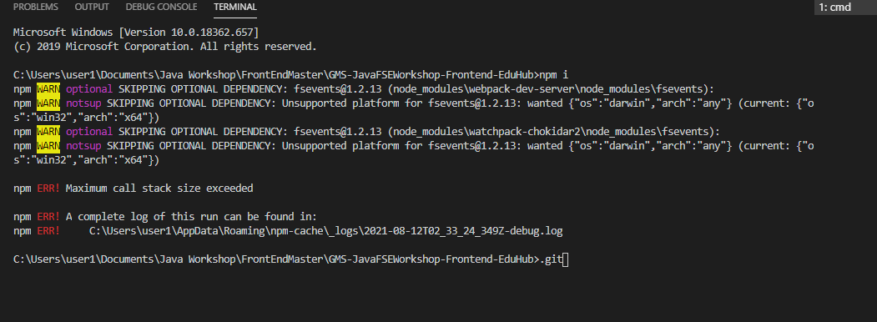

From above, we can see some warnings and errors are listed

1. Give command ‘ npm run build’

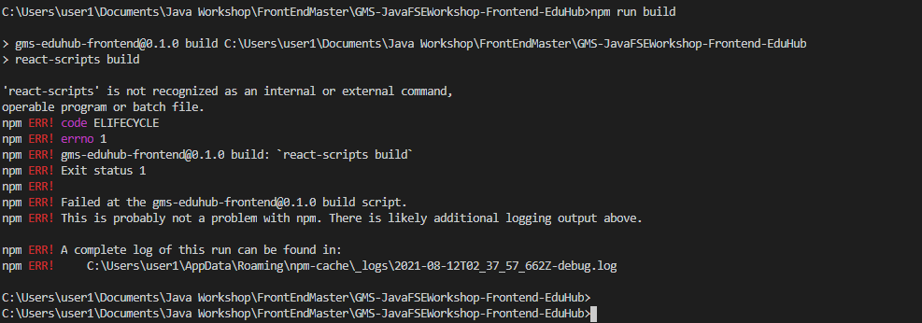 As seen above, errors and warning show reactscript is not installed. To resolve, try command – ‘npm i react-script’

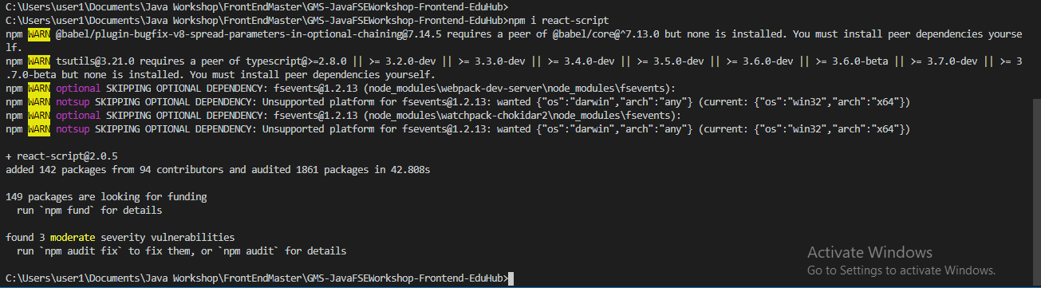

No errors – only warnings are present

1. Give command ‘ npm run build’ again

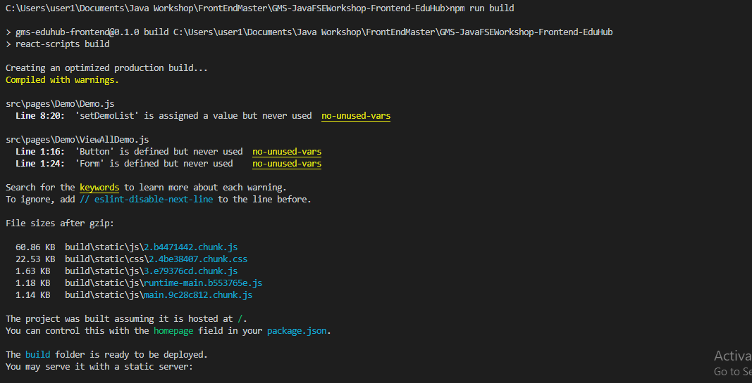

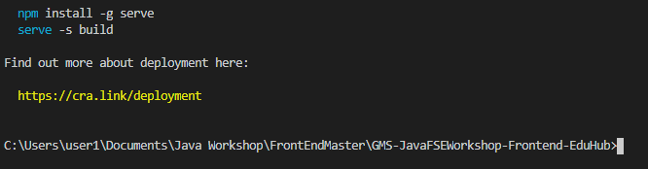

Build completed successfully

9.Give command ‘npm start’

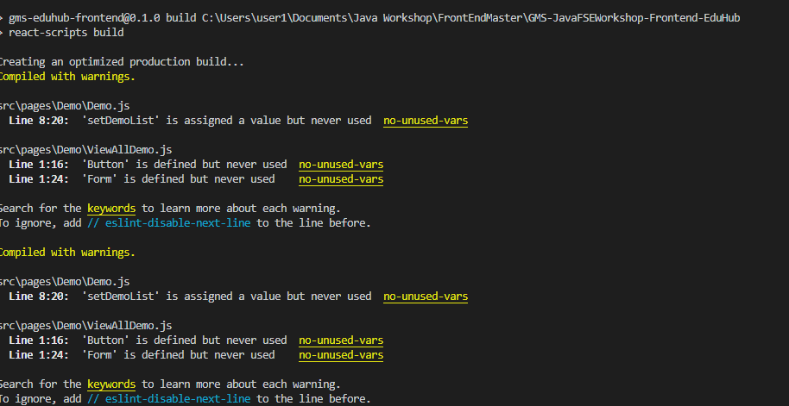

10.The browser should open local host 3000 by default

